https://github.com/adminazhar/HackerRank-Angular-Basic-Certification-Solution

# Angular: Temperature Converter

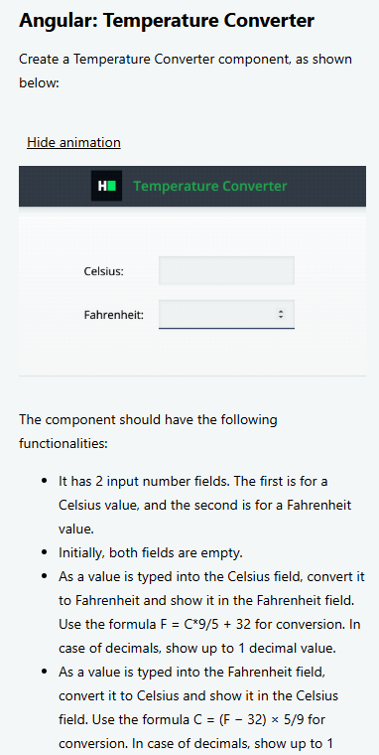

## temperatureConverter.component.ts

import { Component, OnInit } from "@angular/core";

@Component({

  selector: "temperature-converter",

  templateUrl: "./temperatureConverter.component.html",

  styleUrls: ["./temperatureConverter.component.scss"],

})

export class TemperatureConverter implements OnInit {

  c = "";

  f = "";

  constructor() {}

  ngOnInit() {}

  onChange(value: string | null, type: "c" | "f") {

    if (value === null) {

      this.c = "";

      this.f = "";

      return;

    }

    const temperature = Number(value);

    if (type === "c") {

      this.f = ((temperature * 9) / 5 + 32).toFixed(1);

    } else {

      this.c = (((temperature - 32) * 5) / 9).toFixed(1);

    }

  }

}

## temperatureConverter.component.html

<div class="layout-column align-items-center mt-50">

  <section class="layout-row align-items-center justify-content-between">

    <label>Celsius: </label>

    <input

      type="number"

      class="large"

      data-test-id="celsius-input"

      [(ngModel)]="c"

      (ngModelChange)="onChange($event, 'c')"

    />

  </section>

  <section class="layout-row align-items-center justify-content-between">

    <label>Fahrenheit: </label>

    <input

      type="number"

      class="large"

      data-test-id="fahrenheit-input"

      [(ngModel)]="f"

      (ngModelChange)="onChange($event, 'f')"

    />

  </section>

</div>

# Angular: Weather Component

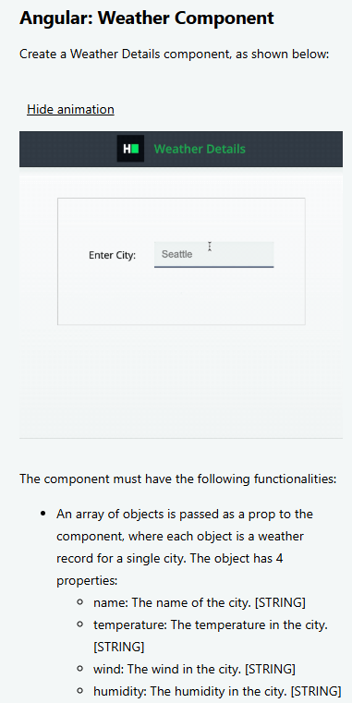

## weatherDetails.component.ts

import { Component, Input, OnInit } from "@angular/core";

@Component({

  selector: "weather-details",

  templateUrl: "./weatherDetails.component.html",

  styleUrls: ["./weatherDetails.component.scss"],

})

export class WeatherDetails implements OnInit {

  @Input() weatherData: data[];

  searchTerm = "";

  searchedData?: data = undefined;

  ngOnInit() {}

  onChange(value: string | null) {

    this.searchedData = this.weatherData.find(

      ({ name }) => name.toLowerCase() === value.toLowerCase()

    );

  }

}

interface data {

  name: string;

  temperature: string;

  wind: string;

  humidity: string;

}

## weatherDetails.component.html

<div class="weather-data layout-column align-items-center mt-50">

  <section class="layout-row align-items-center justify-content-center">

    <label>Enter City: </label>

    <input

      type="text"

      class="large ml-30"

      placeholder="Seattle"

      data-test-id="app-input"

      [(ngModel)]="searchTerm"

      (ngModelChange)="onChange($event)"

    />

  </section>

  <section class="mt-20 layout-row align-items-center justify-content-center">

    <div class="card outlined">

      <div

        *ngIf="searchedData"

        data-test-id="weather-details"

        class="card-text pt-10 layout-row justify-content-between"

      >

        <div class="mt-20 outlined">

          <button class="icon-only mx-2">

            <i class="material-icons">wb_sunny</i>

          </button>

          <span data-test-id="output-temperature" class="temperature">{{

            searchedData.temperature

          }}</span>

        </div>

        <div class="mr-15 mb-15">

          <div data-test-id="output-wind" class="mt-20">

            Wind: {{ searchedData.wind }}

          </div>

          <div data-test-id="output-humidity" class="mt-20">

            Humidity: {{ searchedData.humidity }}

          </div>

        </div>

      </div>

      <div

        *ngIf="searchTerm && !searchedData"

        data-test-id="no-results"

        class="card-text"

      >

        No Results Found

      </div>

    </div>

  </section>

</div>